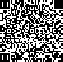[2009] 107 









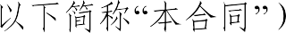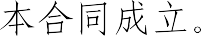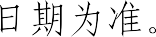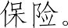

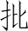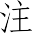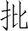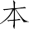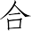

 



 30  

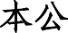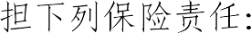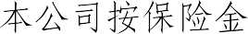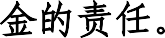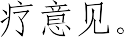



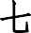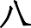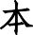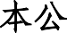

 1

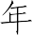

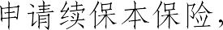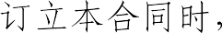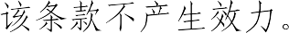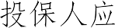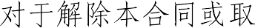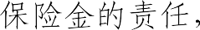

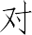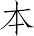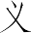





 30 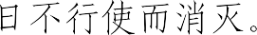

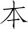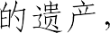





 

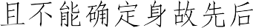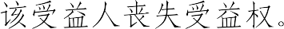

 10 

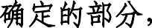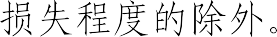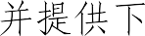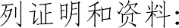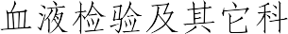



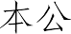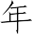

  

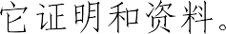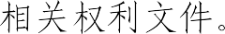

5   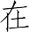 30 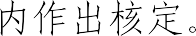 

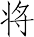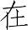

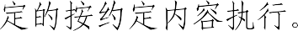

10  

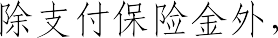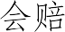

  3 



 60



 2 



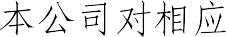

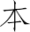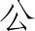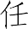

75% 

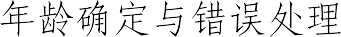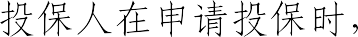

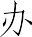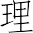

1  

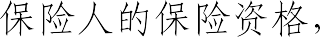



2  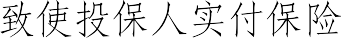



 

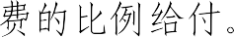

3  

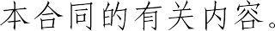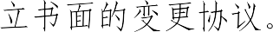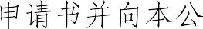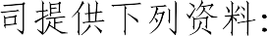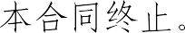

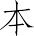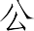

  30 



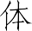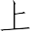

 

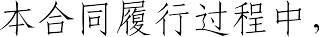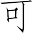



  5  5  

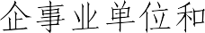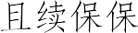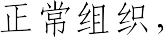

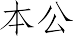

  ICD-10  



# 1

**2** 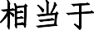 **Binet ** **A **

**3** 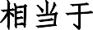 **Ann Arbor ** **I **

**4 **  

# 5 TNM T1N0M0 6



1  

2 

3  



4 90  

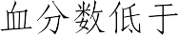 50%







 180 



1 

2 

3    

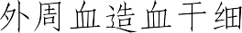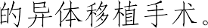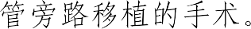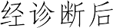

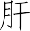

 90  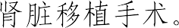

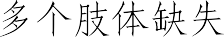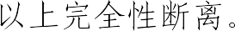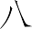

  

1 

2 

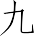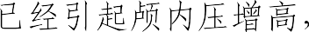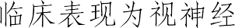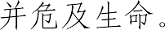3 B  4 

 CT  MRI 

PET  

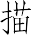

1  



2 

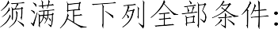

1 

2 

3 

4 





 

  180 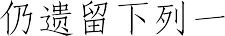





1 

2 

3    





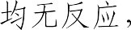  Glasgow coma scale

 5  5 



 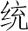 96  

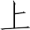





 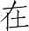 500

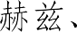 1000  2000 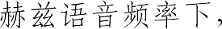 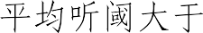 90



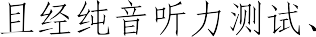

 **0 ** **3 ** 

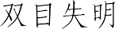



1 

2 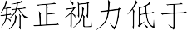 0.02





3 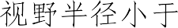 5





180

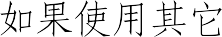

 180 









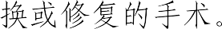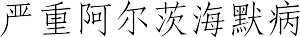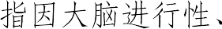



  CT 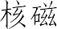

 MRI  PET 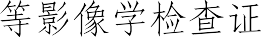

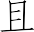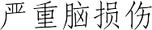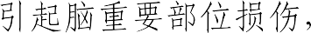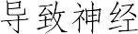

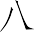

  CT 

MRI  PET 

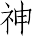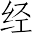

  180 



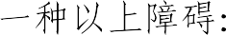

1 

2 

3    

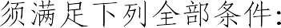

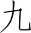

1 

2    

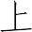

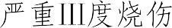



20% 20%  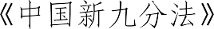 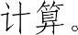





 IV 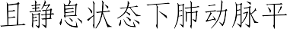

 30mmHg



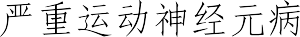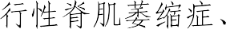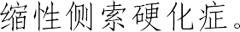



12  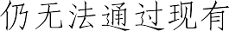



 **0 ** **3 ** 

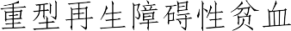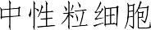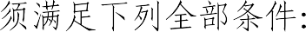



1

2

1 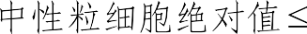

2 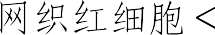 1%

0.5

109 /L

3 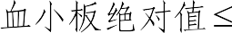 20 109 /L





 

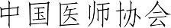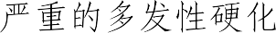

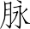

  CT 

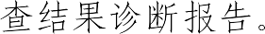

 180 

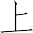



1  

2 

3  

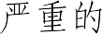 1 



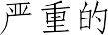 1 

  180  

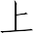

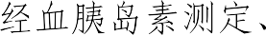 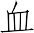 C  C   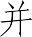  

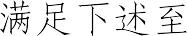

 1

1 

2 

3 

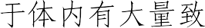

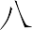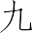

1  4



1 

2 

3 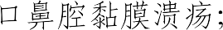

4 

5 

6  

7 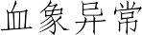 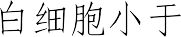 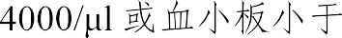 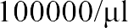

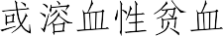

2  2

1  dsDNA 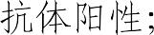



3

30ml

2  Sm 

3 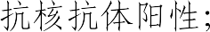

4   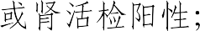

5 C3 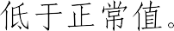

 





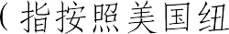

*   180





* 

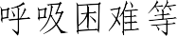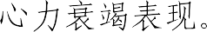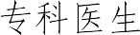

1  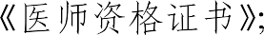

2  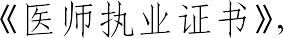 



3 

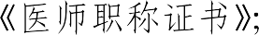

4 

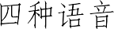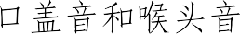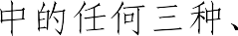

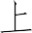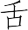

1  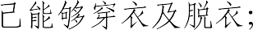

2   



3  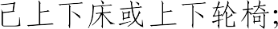



4  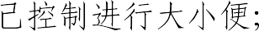

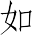

5    

6   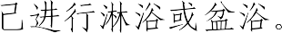

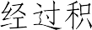

 180 



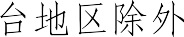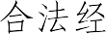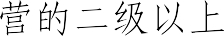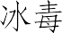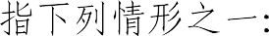

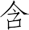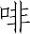

1 

2 

3 

4   

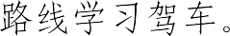

 

1 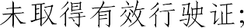

2 

3 

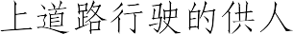

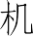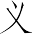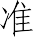

   × 1 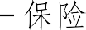

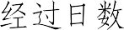 /   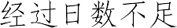 1  1 

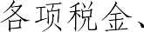

   25%





  



